CENTRAL EAST EDUCATION DIVISION


MATHEMATICS PAPER 1 MARKING SCHEME

- (𝑚² + 2mn₊ 𝑛² ) - 𝑝² M1 Factorising the first bracket
(m + n )² - 𝑝² M1 Factorising difference of perfect square
(m + n -p ) ( m + n +p) M1 Correct factors
A 1 Accuracy (4marks)

2. Question 2
$\frac{1}{ \sqrt{8}}- \frac{1}{\sqrt{18}}$ M 1 rationalising each fraction
$\frac{\sqrt{8}}{8}- \frac{\sqrt{18}}{18}$
$\frac{9\sqrt{8 }- 4\sqrt{18}}{72}$ M1 finding common denominator
$\frac{9⨉2\sqrt{2 }- 4⨉3 \sqrt{2}}{72}$ M1 simplifying the numerator
$\frac{18\sqrt{2 }- 12\sqrt{2}}{72}$ M1 for subtracting surds
$\frac{6\sqrt{2}}{72}$
$\frac{\sqrt{2}}{12}$ A1 for accuracy

OR

$\frac{1}{2\sqrt{2}}- \frac{1}{3\sqrt{2}}$
$\frac{2\sqrt{2}}{8}- \frac{3\sqrt{2}}{18}$
$\frac{\sqrt{2}}{4}- \frac{\sqrt{2}}{6}$
$\frac{3\sqrt{2 }- 2\sqrt{2}}{12}$
$\frac{\sqrt{2}}{12}$
3
$${ S}_{n={2n}^{2}+9n}$$
$$S_{1}={2(1)}^{2}+9(1)$$
a = 11………………M1 finding first term
$$S_{2=2^{2}+9(2)}$$
=8+18…...M1.Finding sum first and second term
a+a+d =26……
11+11+d=26…… M1 finding common difference.
d =26-22
d=4
a+d = 11 +4 =15…..M1 finding second and third term
a+d+d=11 +4+4=19……
: Three terms = 11, 15, 19 (5marks)

Question 4
M = $\frac{VP^{2}}{C - P^{2}}$
$\frac{M}{1}$ = $\frac{VP^{2}}{C - P^{2}}$ M1 clear fraction
VP² = M (C – P²) M1 multiplying RHS
VP² = MC - MP² M1 collecting terms with P together
VP² + MP² = MC M1 square rooting both sides
P² = $\frac{MC}{V+M}$
P =$\sqrt{\frac{MC}{V+M}}$ A1 for accuracy

Question 5
f(x) = 5x + 4
f(a) = 19
f(a) = 5a + 4 M1 for substitution
19 = 5a + 4
19 – 4 = 5a
15 = 5a
a = 3 A1 for accuracy
f(x) = 5x + 4
f (-1) =5(-1) + 4 M1 for substitution
f (-1) = b
b = -5 + 4
= -1 A1 for accuracy

Question number 6.

AB = M1 Finding AB
√(2 −)
2

+
−)
(2 −
2
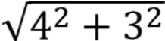

= √25
= 5 Units
BC = M1 Finding AC
√(−2 − 2)

2
(−1 −
1)
+
2
= √9
= 3 Units
A𝐶² B𝐶² = A𝐵 ² Pythagoras Theorem M1 using py to identify right angle
3² + 4² = 5²
9 + 16 = 25
25 = 25
Right angle is at point C ( 2, -1) A1 Accuracy ( 5marks)

Question 7
Join EC M1 for construction C = OE radii M1 For the reason AEF = A C E 56° 24 M1 Angle of alternate segments
OCE = OEC = 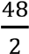= base angles of ISO triangle
ACO = 56 – 24 = 32 A1 accuracy ( 4marks)

Question 8
(x – 5) (x – 3) (x – 3) ≡ Px³ +Qx² + Rx + K
(x – 5) (x² – 6x +9) ≡ Px³ +Qx² + Rx + K M1 expanding LHS
x³ – 6x² + 9x – 5x² 30x – 45 ≡ Px³ +Qx² + Rx + K
x³ – 11x² + 39x – 45 ≡ Px³ +Qx² + Rx + K M1 simplifying
-11x² = Qx² M1 equating corresponding term
-$\frac{-11x^{2}}{x^{2}}= \frac{Qx^{2}}{x^{2}}$
Q = -11 A1 for accuracy

Question 9
Height for Ireen = 1.2x M1 relating ages of the two
Height for Shyreen = x
Sf = $\frac{1.2x}{x}=\frac{1.2}{1}$ M1 finding S.F
Af = $(\frac{1.2}{1})^{2}=\frac{1.44}{1}$ M1 finding A.F
Let y be amount of money Ireen would spend
$$\frac{y}{15000}=\frac{1.44}{1} M1 for simplification$$

y = 1.44 ⨉ 15000
y = K 21, 600.00 A1 for accuracy

Question 10
Translation vector =$\left(\begin{aligned} 3 \\ -5\end{aligned}\right)$ M1
A’ = $\left(\begin{aligned}1 \\ 2\end{aligned}\right)+\left(\begin{aligned} 3 \\ -5\end{aligned}\right)$ = $\left(\begin{aligned} 4 \\ -3\end{aligned}\right)$ ⟾ (4, - 3) M1
B’ = $\left(\begin{aligned}-2 \\ 3\end{aligned}\right)+\left(\begin{aligned} 3 \\ -5\end{aligned}\right)$ = $\left(\begin{aligned} 1 \\ -2\end{aligned}\right)$ ⟾ (1, - 2) M2
C’ = $\left(\begin{aligned}-2 \\ 4\end{aligned}\right)+\left(\begin{aligned} 3 \\ -5\end{aligned}\right)$ = $\left(\begin{aligned} 1 \\ -1\end{aligned}\right)$ ⟾ (1, - 1) A1

(5 marks for finding image of each point)

Question 11

Method 1
𝑥² − 4𝑥 + 3 = 0
𝑥² – 4x = -3 M1 completing square
𝑥² – 4x +4 = +4 -3 M1 factorising LHS and simplifying
(x- 2)² = 1 RHS
(X-2)² -1 =0 M1 Finding coordinates x- 2=0 x=2
Turning point coordinates = (2, -1) A1 accuracy (4marks)

Method 2 using the formula 𝑥² - 4x +3

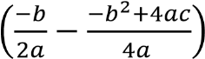
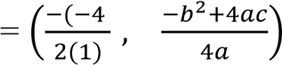
M1 identifying a,b and c

Turning Point =
a = 1 b= -4 c= 3
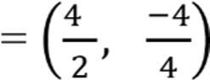 M1 Substituting in the formula

(2, -1) M1 Simplifying
M1 Finding the coordinates

A1 Accuracy (5marks)

Question 12
$\left(\begin{matrix}3 & 3 \\ -1 & -1\end{matrix}\right)$ $\left(\begin{matrix}3 & 3 \\ -1 & -1\end{matrix}\right)$ ⁼ a$\left(\begin{matrix}3 & 3 \\ -1 & -1\end{matrix}\right)$ M1 correct substitution
3×3+3×-1=3a M1 row by column multiplication
M1 multiplication of scalar by matrix
9-3=3a M1 correct equation to get value
a=3 A1 accurancy

QUESTION 13

a = 2, b = -8 and c = -7
$$x=\frac{-b±\sqrt{b^{2}-4ac}}{2a}$$
M1 for correct substitution
$$x=\frac{-(-8)±\sqrt{{(-8)}^{2}-4(2)(-7)}}{2(2)}$$
$$x=\frac{8±\sqrt{64-(-56)}}{4}$$
M1 for simplification

$$x=\frac{8±\sqrt{64+56}}{4}$$
$$x=\frac{8±\sqrt{120}}{4}$$
M1 for finding square root
$$x=\frac{8±10.9544512}{4}$$
$$\frac{8+10.9544512}{4} or \frac{8-10.9544512}{4}$$
= 4.7386128 or – 0.7386128
x = 4.74 or – 0.74
A2 for accuracy

Question 14
$\frac{{sin60}^{0}{tan45}^{0}}{{tan30}^{0}{cos30}^{0}}$ =$\frac{\frac{\sqrt{3}}{2} ×1}{\frac{1}{\sqrt{3}} × \frac{\sqrt{3}}{2}}$ M1 identifying special angles
= $\frac{\frac{\sqrt{3}}{2}}{\frac{1}{2}}$ M1 for simplification
= $\frac{\sqrt{3}}{2} ⨉$ $\frac{2}{1}$ M1 for upsetting the divisors
= $\sqrt{3}$ A1 for accuracy

Question 15
$\frac{1}{2 }$ ×5×6 Sin B=12 M1 equating to sine area rule

$15sin B=12$ M1 substituting correctly
B=Sin $(\frac{12}{15}$) M1 for simplification
B=53.1130 M1 finding correct angle B
B= 53 A1 for accuracy

QUESTION 16
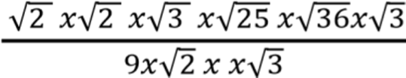 M1 factorising the numerators
$\frac{=2×3×5×6}{9√6}$ M1 factorising the denominator

$\frac{180}{9\sqrt{6}}$ M1 dividing by the numerator

=$\frac{20}{\sqrt{6}}$ M1 simplifying
A1 accurancy

Question 17
M = $\frac{kh}{r^{2}}$ M1 writing joint variation
500 = $\frac{50k}{2^{2}}$ M1 for substitution
500 = $\frac{50k}{4}$ M1 simplification to find constant
2000 = 50k
k = 40
M = $\frac{40h}{r^{2}}$ M1 substuting k into law
M = $\frac{40 (10)}{4^{2}}$ M1 simplification
M = $\frac{400}{16}$
M = 25g A1 Accuracy

Question 18
2800l = 2 800 000cm³
1.4m = 140cm M1 changing litres to cubic centimeter
V = ∏r²h
2 800 000 = $\frac{22}{7}$ ⨉ 140 ⨉ 140 ⨉ h M1 finding height
19 600 000 = 431 200h M1 equating the volumes
h = $\frac{19600000}{431200}$ M1 substitution
h = 45.4545455
h = 45.5cm
Height of water remaining
45.5 – 40 = 5.5cm
V = ∏r²h
Volume = $\frac{22}{7}$ ⨉ 140 ⨉ 140 ⨉ 5.5 M1 for substitution
= $\frac{2371600}{7}$
= 338 800cm³
1l = 1000cm³
= $\frac{338800}{1000}$
= 338.8l left in the tank A1 for accuracy

Question 19

r
3cm
8cm
O
r

.

r² = 3² + 4² M1 substitution into correct Pythagoras theorem
= 9 + 16 M1 simplification
= 25 M1 finding square of r
r =$\sqrt{25}$ M1 for square rooting
= 5cm A1 accuracy
The radius is 5cm long

Question 20
M1 for shading correct unwanted region of 2x +y≤6
M1 for shading correct unwanted region of y>x
M1 shading correct unwanted region of y≤3
M1 drawing correct lines A1 for accuracy

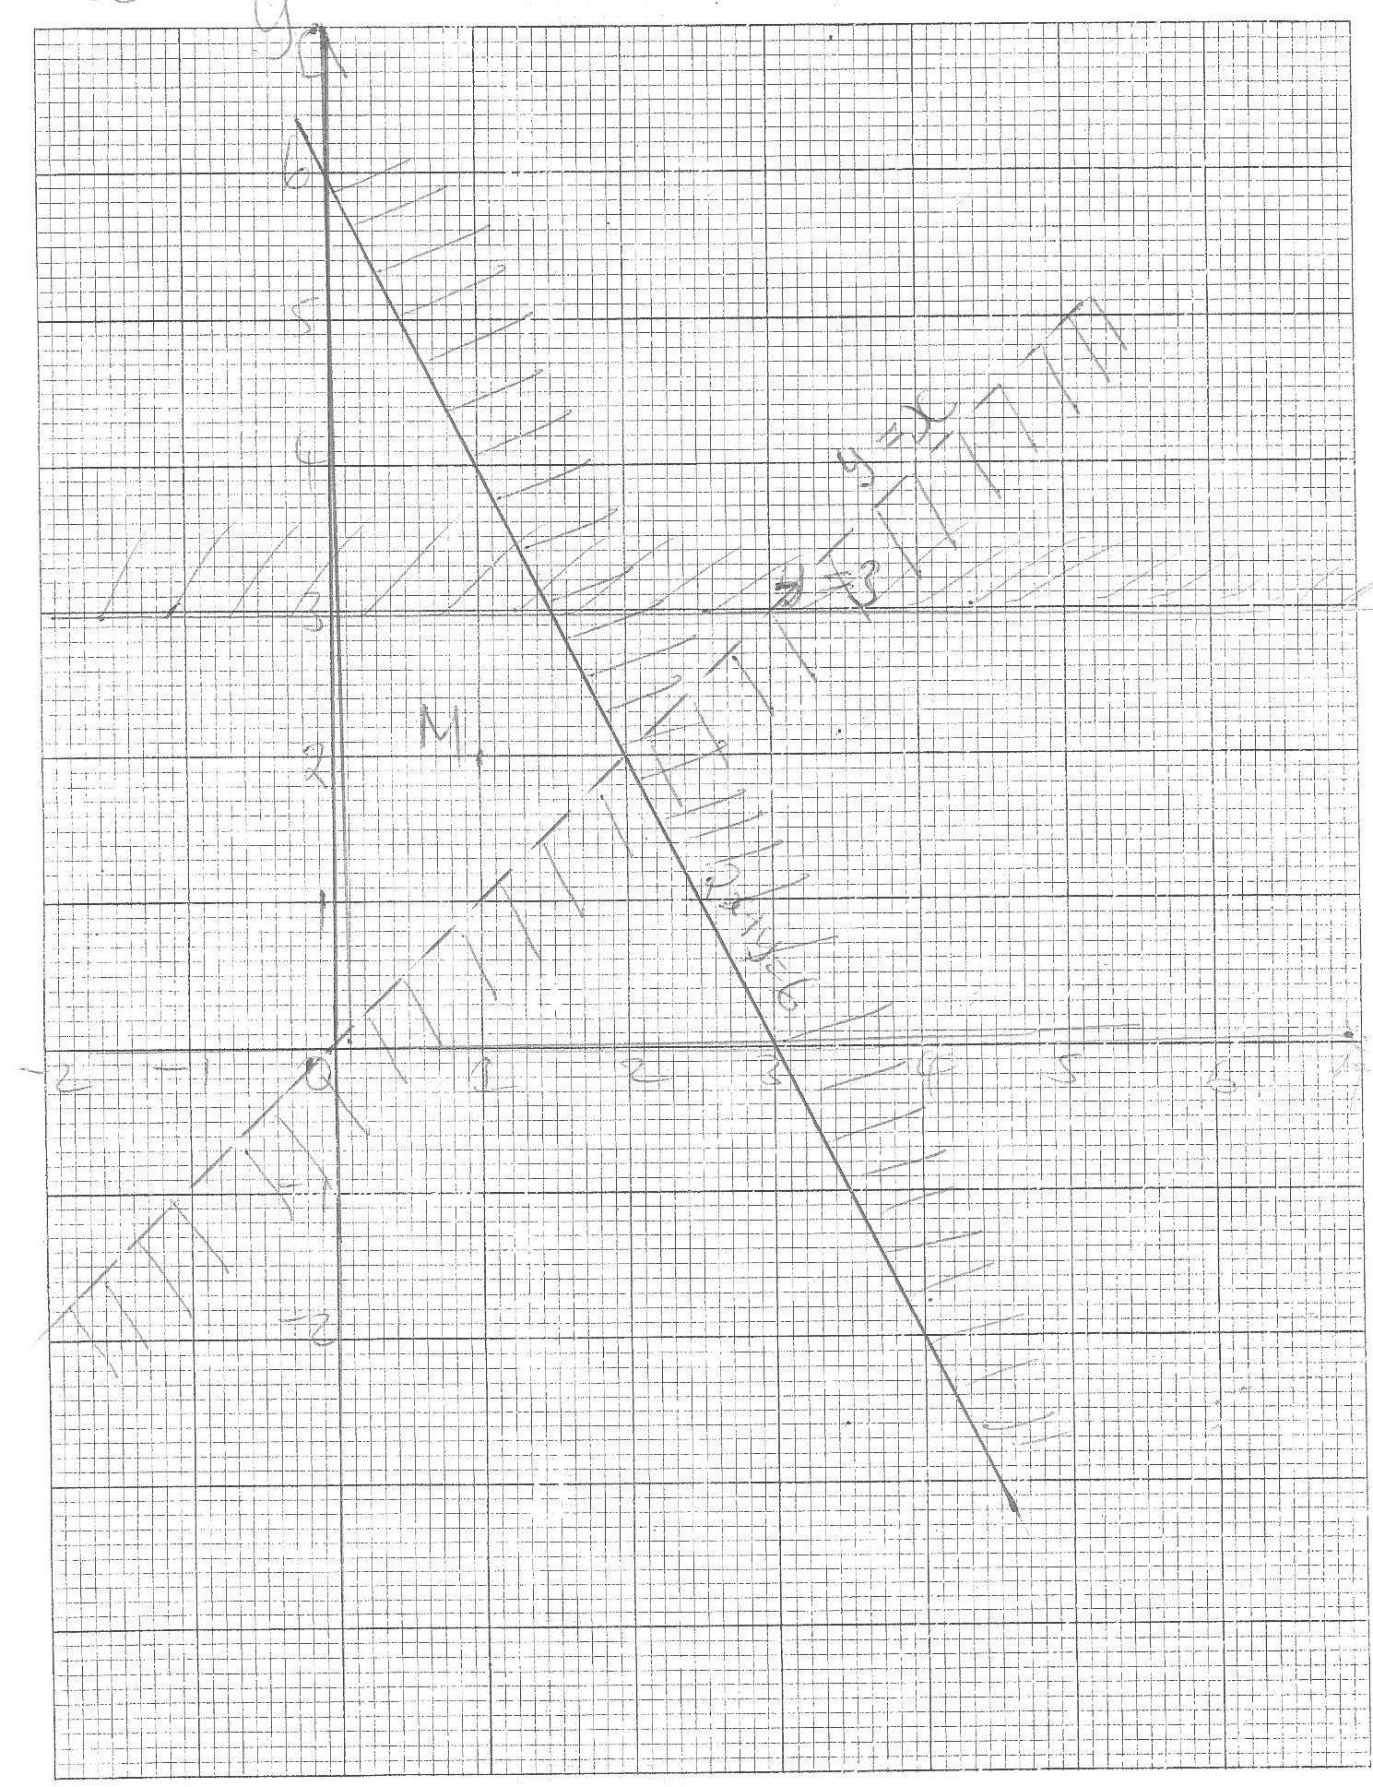

x- t = 0 x= t M1 equating x to t

M1 Substituting in the polynomials
𝑡³ - 𝑡² + t + 9 = 𝑡³ – 4t + 3 M1 equating to zero
0 = 𝑡² – 5t – 6 M1 Factorising 0 = (t – 6) (t + 1) M1 Finding t t– 6 =0 t + 1 = 0 t = 6 t = - 1
t = -1 or 6 Accuracy A1 (7marks)

- 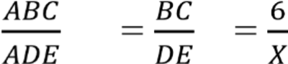 M1 Proportion of sides

M1 Equating sides to area ration
M1 Squaring sides to equate to area ratio

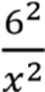
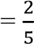
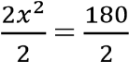
M1 Finding the value of x

𝑥²= 90

𝑥²=90
x = 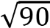
value of x 9.4868
B1 A1 Correcting to 1 decimal place and Accuracy (6marks)

 M1 Factorising the numerators
M1 Factorising the denominators
M1 dividing by common factors
M1 Simplifying the numerator and denomerator
A1 Accuracy

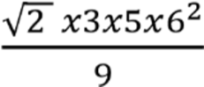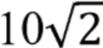

17.
Class | Frequency
3-7 | 2
8-12 | 5
13-17 | 3
18- 22 | 7
M 1 correct rows and column
M1 correct classes
M1 correct frequency
A1 Accuracy

∑ 𝑓= 2 +5+3 + 1 M1 Adding frequency

= 11 passengers ( 6marks)

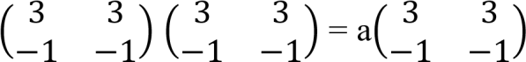
- M1 Correct substitution

3 x 3 + 3 x -1 = 3 x a M1 row by column multiplication
M1 Multiplication of scalar by matrix 9 – 3 = 3a M1 correct equation to get value

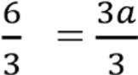 A1 accurancy
a = 2

- x 5 x 6 sin 𝐵 = 12 M1 equating to sine area rule
15sin 𝐵=12 M1 substituting correctly
B = 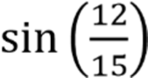 M1 simplify correctly
B = 53.1130 M1 finding angle B correct to the nearest

53° M1 Accuracy degree (5marks)

20 M1 Shading correct unwanted region of 2𝑥 + 𝑦 ≤ 6
M1 Shading correct unwanted region of y> 𝑥
M1 Shading correct unwated region of y ≤ 3

A1 Accuracy (4marks)
20.


